ISSUE-TRACKER (JavaScript Project)
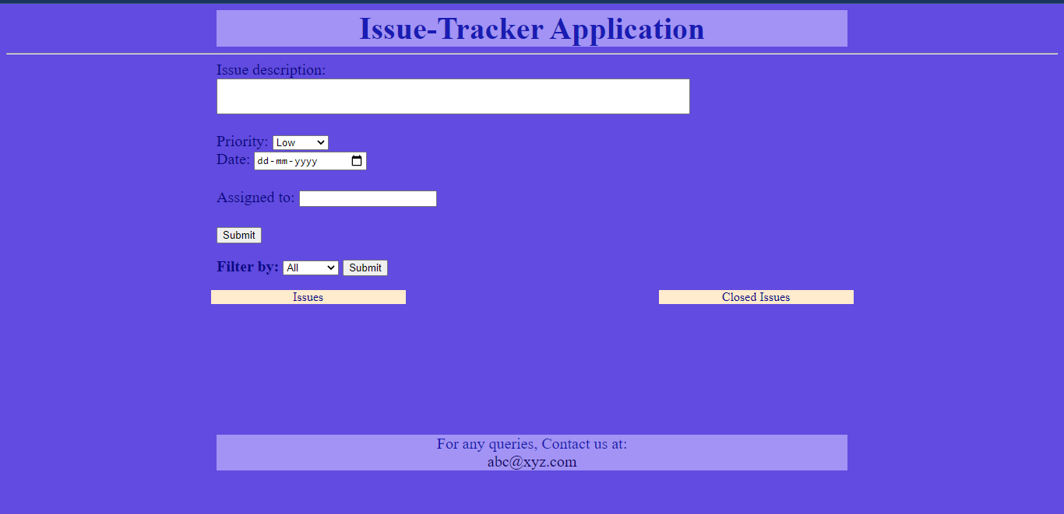

Objective 1:
Ability to create new issues.
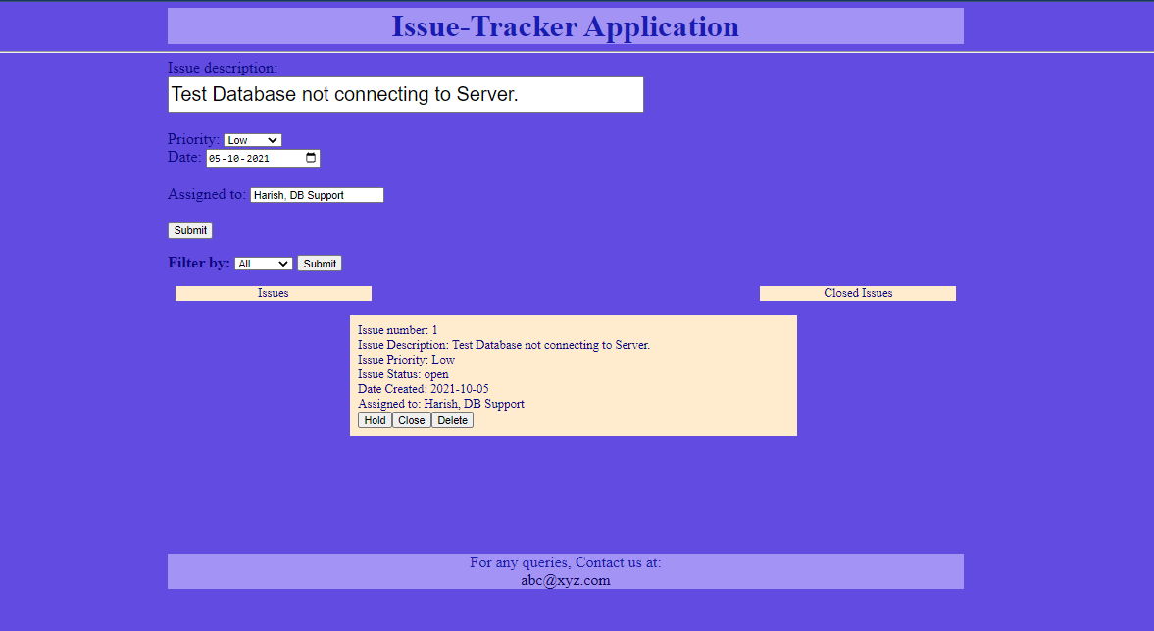

Objective 2:
List the issues in the order of creation
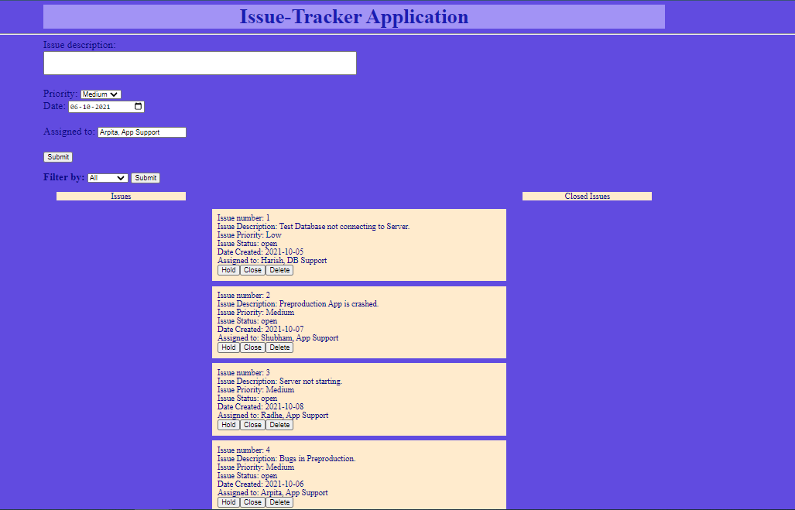

Objective 3:
Issue can be closed
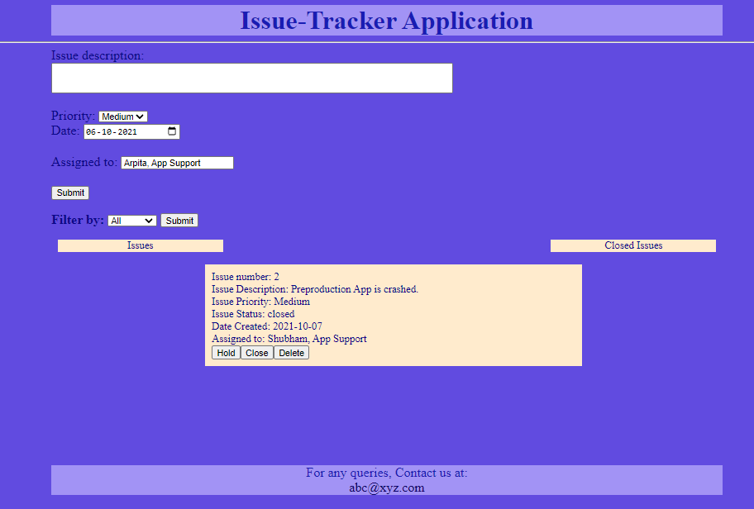

Objective 4:
Issue closed is shown in a separate tab
Non-closed issues (Issues) | Closed Issues (Closed Issues)
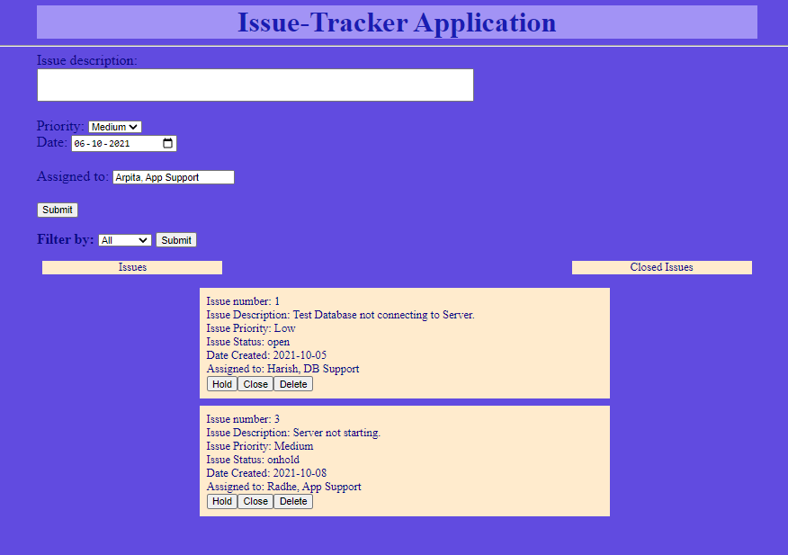 | 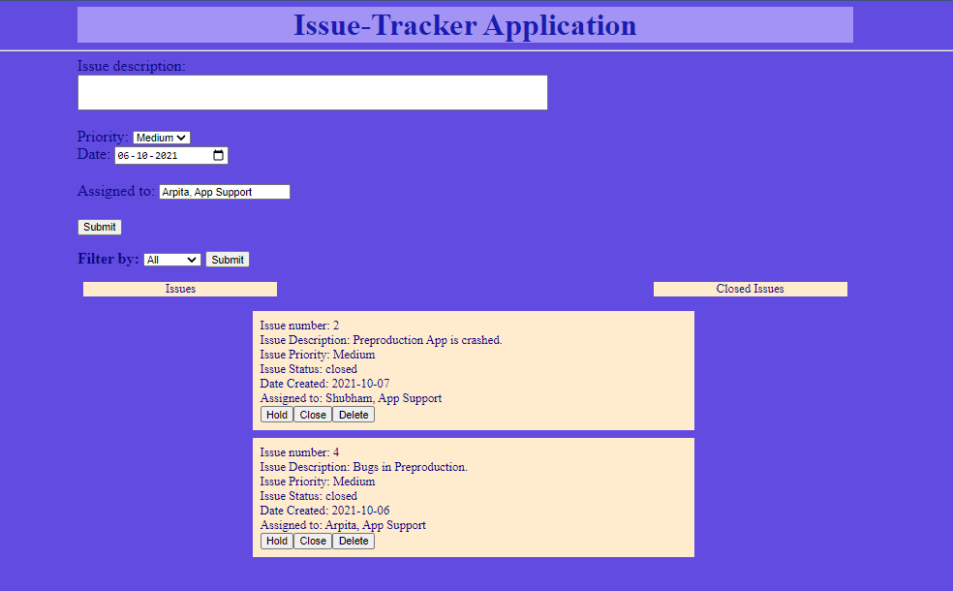

Objective 5:
Issue on hold cannot be deleted
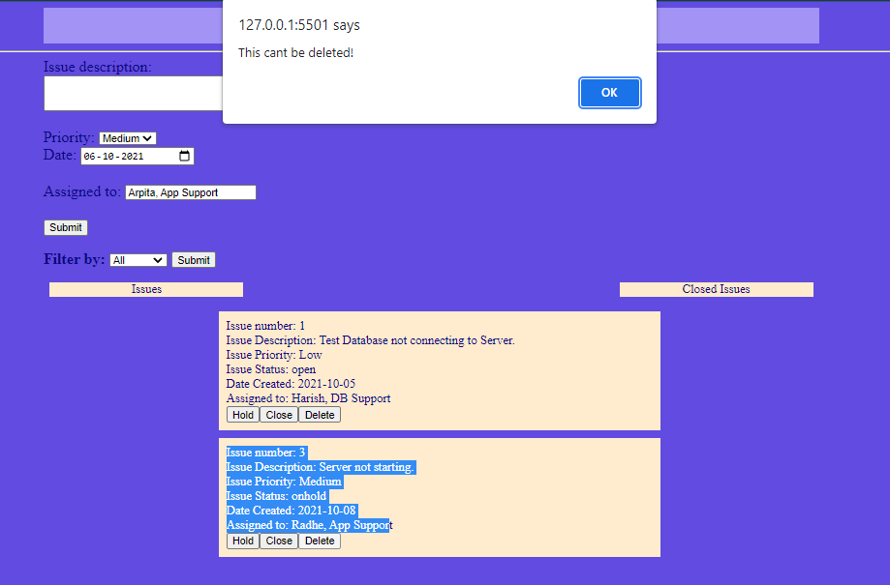

Objective 6:
Issue status can be changed


Objective 7:
Ability to filter issues created based on priority
- Filtering non-closed “Low” priority issues:
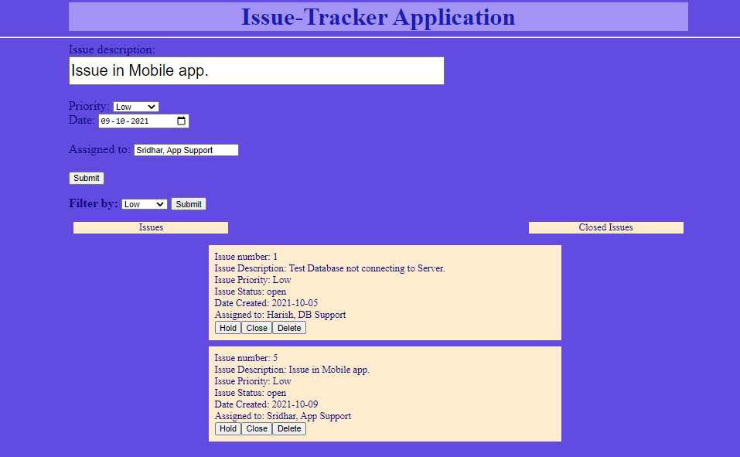
- Filtering non-closed “Medium” priority issues:
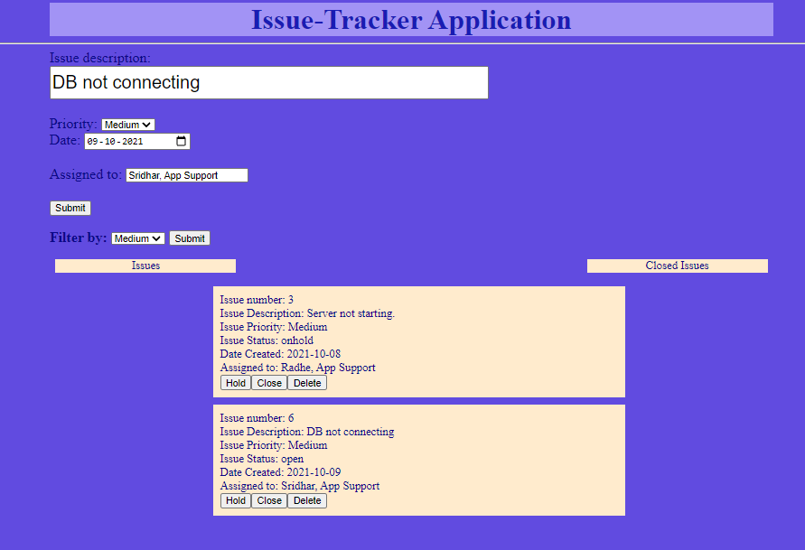

- Filtering closed “Medium” priority issues:
